Experiment 20: infrared remote control
Note: the IRremote folder into the compiler to install the directory under the Arduinolibraries.

For example：C:\Program Files\Arduino\libraries

1、Infrared receiving head introduction
一、What is the infrared receiver head?
From the infrared remote control signal is a series of binary pulse code. In order to make it from other infrared signal interference in wireless transmission process, usually first its modulation on the specific carrier frequency, and then by the infrared emitting diodes emitted, and the infrared receiving device to filtering the clutter, they receive the specific frequency signal and restore it to the binary pulse code, also is demodulation.
二、Working principle
The built-in receiver will transmit the infrared emission tube light signal into a weak signal, this signal through the IC internal amplifier amplification, and then through the automatic gain control, band-pass filtering, demodulation, waveform shaping after the original encoding to restore the original signal output by the receiver signal output pin input to the electrical appliances on the encoding recognition circuit.

三、Pin and connection of infrared receiving head
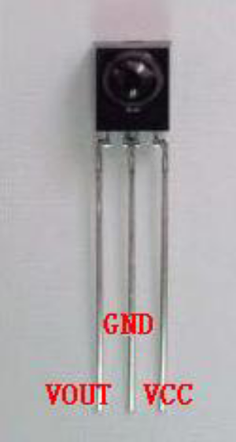
The infrared receiving head has three pins as follows:
When using the VOUT to the analog port, GND received the experimental board GND, +5v. received the VCC on the experimental board
Infrared remote control experiment

1, experimental device

As for the infrared remote control: 1

Of the infrared receiving head: 1

The LED of light: 6

The 220 resistor: 6

The colorful line: some of the bread
- Experimental connection
First, the board is connected; then the infrared receiver head in accordance with the above method, the VOUT connected to the digital 11 pin, the LED lamp through the resistor connected to the digital pin 2,3,4,5,6,7. back to complete the circuit part of the connection.

3、Experimental principle
To decode a remote controller must be aware of the remote control of the encoding way. This product is used to control the code of the way: NEC agreement. Following the introduction of the NEC protocol:
·NEC protocol description: features: (1) 8 address bits, 8 bit command

(two) for the 2 time in order to address the reliability address bit and the command bit

(3) pulse position modulation

(4) carrier frequency 38kHz

(5) each time for the 1.125ms ring 2.25ms
·Logic 0 and 1 are defined as follows.：
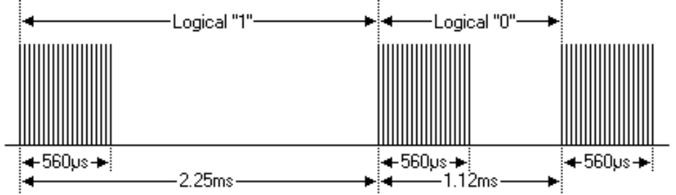
·Press the launch pulse at once:
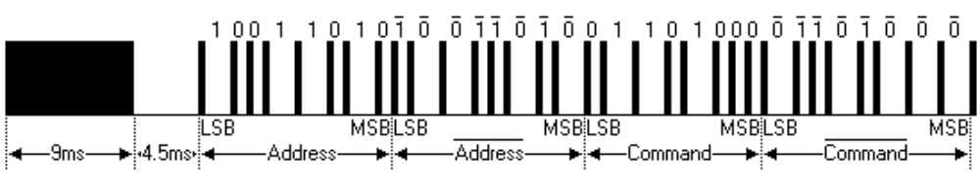
The image above shows a typical pulse sequence of NEC. Note: this first send LSB (the most low) protocol. In the above pulse transmission of the address for the 0x59 command 0x16. a message is from a high level of 9ms, then there is a low level of 4.5ms, and the command code. The address and command code. Second times all bits are taken back, can be used for the confirmation of the message. Because every point and it takes anti length repeat, you can ignore the if you are not interested. Take the counter, you can also expand the address and command, to every 16!
Key press a period of time before the release of the launch pulse：
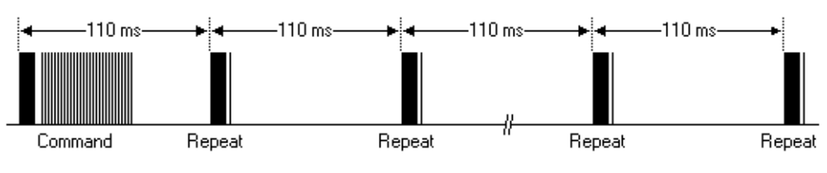
A command sent once, even on the remote control button is still pressed. When the button has been pressed, the first 110ms of the pulse and the image above, after each 110ms repeat code transmission.
·repetitive pulse
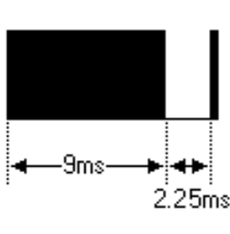
Note: pulse waveform of integration into the receiving head, because integration receiving head to disobey decoding, signal amplifying and shaping, so pay attention to: in the absence of infrared signal, and the output end of the signal for a high level to low level, so its output signal level just and a transmitting terminal are anti. Receiving pulse end we can seen by the oscilloscope and see the waveform of program understanding.

Line connection diagram：
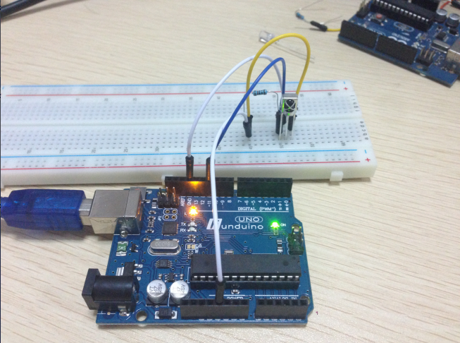
Program code：
#include <IRremote.h>
int RECV_PIN = 11;
int LED1 = 2;
int LED2 = 3;
int LED3 = 4;
int LED4 = 5;
int LED5 = 6;
int LED6 = 7;
long on1 = 0x00FFA25D;
long off1 = 0x00FFE01F;
long on2 = 0x00FF629D;
long off2 = 0x00FFA857;
long on3 = 0x00FFE21D;
long off3 = 0x00FF906F;
long on4 = 0x00FF22DD;
long off4 = 0x00FF6897;
long on5 = 0x00FF02FD;
long off5 = 0x00FF9867;
long on6 = 0x00FFC23D;
long off6 = 0x00FFB047;
IRrecv irrecv(RECV_PIN);
decode_results results;
// Dumps out the decode_results structure.
// Call this after IRrecv::decode()
// void * to work around compiler issue
//void dump(void *v) {
// decode_results *results = (decode_results *)v
void dump(decode_results *results) {
int count = results->rawlen;
if (results->decode_type == UNKNOWN)
{
Serial.println("Could not decode message");
}
else
{
if (results->decode_type == NEC)
{
Serial.print("Decoded NEC: ");
}
else if (results->decode_type == SONY)
{
Serial.print("Decoded SONY: ");
}
else if (results->decode_type == RC5)
{
Serial.print("Decoded RC5: ");
}
else if (results->decode_type == RC6)
{
Serial.print("Decoded RC6: ");
}
Serial.print(results->value, HEX);
Serial.print(" (");
Serial.print(results->bits, DEC);
Serial.println(" bits)");
}
Serial.print("Raw (");
Serial.print(count, DEC);
Serial.print("): ");

for (int i = 0; i < count; i++)
{
if ((i % 2) == 1) {
Serial.print(results->rawbuf[i]*USECPERTICK, DEC);
}
else
{
Serial.print(-(int)results->rawbuf[i]*USECPERTICK, DEC);
}
Serial.print(" ");
}
Serial.println("");
}

void setup()
{
pinMode(RECV_PIN, INPUT);
pinMode(LED1, OUTPUT);
pinMode(LED2, OUTPUT);
pinMode(LED3, OUTPUT);
pinMode(LED4, OUTPUT);
pinMode(LED5, OUTPUT);
pinMode(LED6, OUTPUT);
pinMode(13, OUTPUT);
Serial.begin(9600);

irrecv.enableIRIn(); // Start the receiver
}

int on = 0;
unsigned long last = millis();

void loop()
{
if (irrecv.decode(&results))
{
// If it's been at least 1/4 second since the last
// IR received, toggle the relay
if (millis() - last > 250)
{
on = !on;
// digitalWrite(8, on ? HIGH : LOW);
digitalWrite(13, on ? HIGH : LOW);
dump(&results);
}
if (results.value == on1 )
digitalWrite(LED1, HIGH);
if (results.value == off1 )
digitalWrite(LED1, LOW);
if (results.value == on2 )
digitalWrite(LED2, HIGH);
if (results.value == off2 )
digitalWrite(LED2, LOW);
if (results.value == on3 )
digitalWrite(LED3, HIGH);
if (results.value == off3 )
digitalWrite(LED3, LOW);
if (results.value == on4 )
digitalWrite(LED4, HIGH);
if (results.value == off4 )
digitalWrite(LED4, LOW);
if (results.value == on5 )
digitalWrite(LED5, HIGH);
if (results.value == off5 )
digitalWrite(LED5, LOW);
if (results.value == on6 )
digitalWrite(LED6, HIGH);
if (results.value == off6 )
digitalWrite(LED6, LOW);
last = millis();
irrecv.resume(); // Receive the next value
}
}

5, program function

The remote control launched encoding pulse decoding, according to the results of the decoding of the corresponding action to perform.

Experiment screenshot:
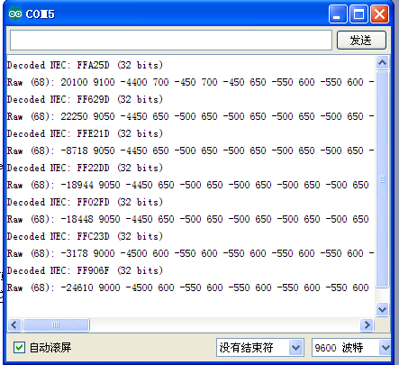
note：Put the IRremote folder in the compiler to install the Arduinolibraries in the directory.。
For example ：C:\Program Files\Arduino\libraries

